User Research

1. Research Objective
The purpose of this user research was to understand the challenges experienced by students and other university service users when accessing services such as the Registry, Finance Office, Clinic, and Accommodation Office. The research aimed to identify common pain points associated with the current physical queueing system and gather user expectations for a Virtual Queue Management Mobile Application.
The findings from this research will guide the design of a user-centered mobile application that improves queue management, reduces waiting time, enhances transparency, and provides a better overall user experience.

2. Research Methodology
A mixed-method user research approach was adopted using a structured questionnaire distributed through Google Forms. The questionnaire contained both closed-ended and opinion-based questions designed to capture participants' experiences with physical queues at university service points and their expectations for a virtual queue management system.
A total of 14 participants completed the questionnaire but the form is still circulating so we are expecting more. The respondents included students, teaching staff, non-teaching staff, and visitors, ensuring that perspectives from different university user groups were represented.
The collected responses were analyzed using descriptive statistics generated by Google Forms, including percentages and response frequencies. The results were then examined to identify recurring themes, user needs, and opportunities fo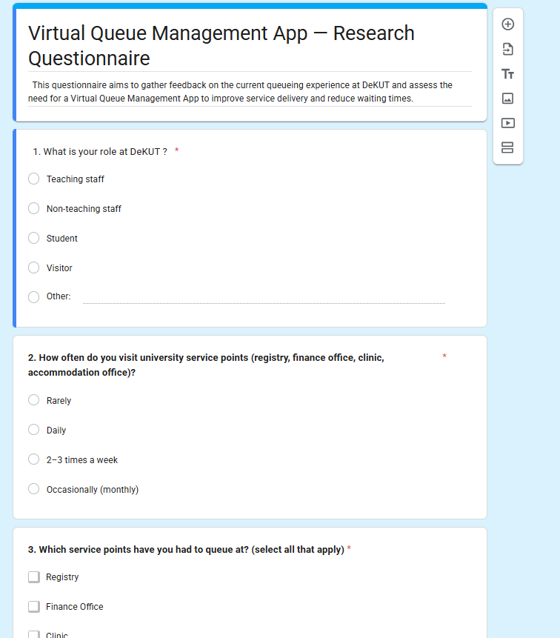r improving the queueing experience through a mobile application.

OUR GOOGLE FORM

3. Participant Summary
A total of 14 participants took part in the study.
User Group | Number of Participants | Percentage
Students | 9 | 64.3%
Non-Teaching Staff | 3 | 21.4%
Teaching Staff | 1 | 7.1%
Visitors | 1 | 7.1%
Total | 14 | 100%

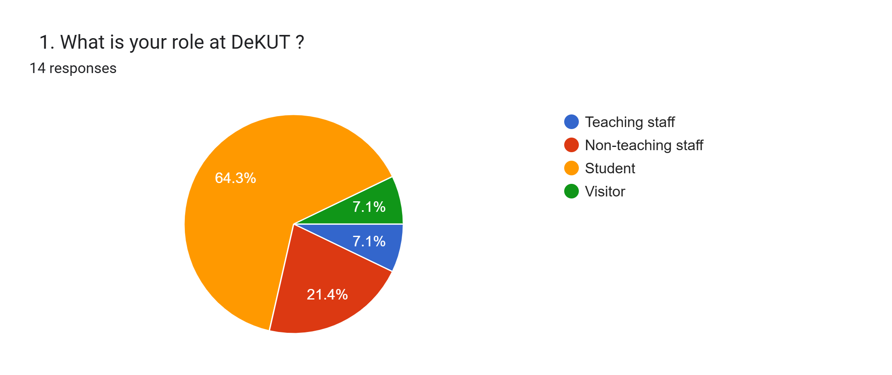
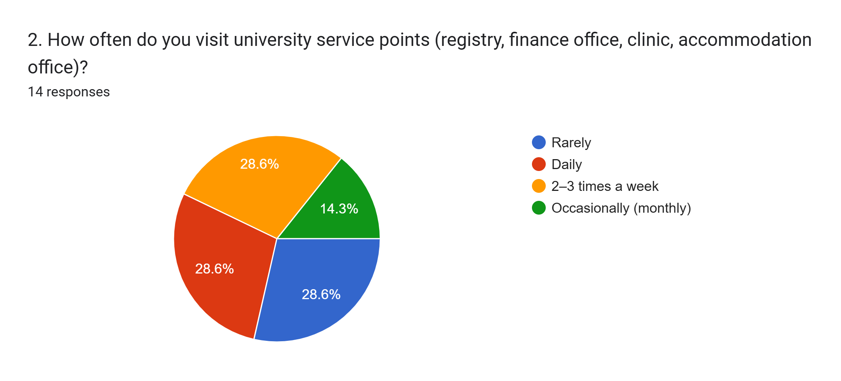

Participant Profile
The majority of respondents were students (64.3%), who are the primary users of university service points and the main target audience for the proposed Virtual Queue Management Mobile Application. The inclusion of teaching staff, non-teaching staff, and visitors provided additional perspectives on queue management challenges and service accessibility.

